PROJECT REPORT
“CRYPTOGRAPHY AND IT’S
APPLICATION IN RANGE EOTS”

INTEGRATED TEST RANGE
DEFENSE RESEACH AND DEVELOPMENT ORGANISATION
CHANDIPUR - 756025

Under the Guidance of
Dr Arun Kumar Ray
(Scientist-G, Group Director, EOTS)

Under the Supervision of
Shri Ganesh Ramani
(Scientist – E, EOTS)

Submitted By
Subhashree Biswal
(Computer Science Engineering, VSSUT
Regd no. – 2202041068)
Namrata Bhoi
(Electronics And Telecommunication Engineering, VSSUT
Regd no. – 2202070122)

Certificate

This is to certify that Subhashree Biswal (CSE) and Namrata Bhoi (ETC) from Veer Surendra Sai University of Technology (VSSUT), Burla, have successfully completed a summer internship training and submitted a project report on “Cryptography and its Applications in Range EOTS” under the Department of Electro-Optical Tracking System (EOTS) of the Integrated Test Range (ITR), DRDO, Chandipur, from 2nd June 2025 to 1st July 2025.
During the internship, they explored, applied secure communication, investigated and implemented efficient encryption and authentication schemes that enhance the confidentiality and integrity of real-time sensor data gathered by Range EOTS, ensuring that only authorized systems and operators have access to the data. They successfully demonstrated key management protocols along symmetric and asymmetric cryptographic algorithms.
Throughout their project, they were highly sincere, hardworking, and inquisitive in their efforts to design and test these solutions.
I wish them every success in life.

Shri Ganesh Ramani Dr Arun Kumar Ray
( Scientist - E, EOTS ) (Scientist - G, Group Director, EOTS)

Acknowledgment

We owe our sincere gratitude to all those who have been a source of encouragement and support throughout this project. We are extremely grateful to Dr Arun Kumar Ray, Scientist-G, GD, EOTS division of Integrated Test Range for having suggested the topic of our project and for his persistent guidance and direction.

We are indebted to Shri Ganesh Ramani, Scientist E of EOTS Divison of ITR for their constant help and motivation right from the beginning of this project until this stage. Their valuable suggestions are the most important input which has assisted in all respects. We are immensely grateful to our parents, whose support has led us to successfully utilize this opportunity.

Subhashree Biswal
(Computer Science Engineering, VSSUT)

Namrata Bhoi
(Electronics And Telecommunication Engineering, VSSUT

DRDO
DRDO is the R&D wing of Ministry of Defense, Govt of India, with a vision to empower India with cutting-edge defense technologies and a mission to achieve self-reliance in critical defense technologies and systems, while equipping our armed forces with state-of-the-art weapon systems and equipment in accordance with requirements laid down by the three Services. DRDO's pursuit of self-reliance and successful indigenous development and production of strategic systems and platforms such as Agni and Prithvi series of missiles; light combat aircraft, Tejas; multi-barrel rocket launcher, Pinaka; air defense system, Akash; a wide range of radars and electronic warfare systems; etc., have given quantum jump to India's military might, generating effective deterrence and providing crucial leverage.

"Balasya Mulam Vigyanam"—the source of strength is science-drives the nation in peace and war. DRDO has firm determination to make the nation strong and self-reliant in terms of science and technology, especially in the field of military technologies. DRDO was formed in 1958 from the amalgamation of the then already functioning Technical Development Establishment (TDEs) of the Indian Army and the Directorate of Technical Development & Production (DTDP) with the Defense Science Organization (DSO). DRDO was then a small organization with 10 establishments or laboratories. Over the years, it has grown multi-directionally in terms of the variety of subject disciplines, number of laboratories, achievements and stature.

Today, DRDO is a network of around 41 laboratories and 5 DRDO Young Scientist Laboratories (DYSLs), which are actively engaged in the development of advanced defense technologies across diverse disciplines. These include aeronautics, armaments, electronics, combat vehicles, engineering systems, instrumentation, missiles, advanced computing and simulation, special materials, naval systems, life sciences, training, information systems, and agriculture. Several major projects—such as the development of missiles, armaments, light combat aircraft, radars, and electronic warfare systems—are currently underway, and significant achievements have already been made in many of these areas.

Integrated Test Range

At the Integrated Test Range (ITR), the safe and successful evaluation of rockets, missiles, and airborne weapon systems depends on transmitting large volumes of highly sensitive data between test articles and range instrumentation in real-time. Throughout a mission, Electro-Optical Tracking Systems (EOTS), radars, telemetry antennas, and central control computers continuously capture and relay vital information such as the precise location, trajectory, and health parameters of the test vehicle. In this process, cryptography plays an indispensable role by ensuring that all critical communications and data exchanges remain secure, authentic, and free from tampering or interception. Techniques like symmetric and asymmetric encryption help protect telemetry and control links against unauthorized access and eavesdropping, guaranteeing confidentiality across the entire communication chain. Digital signatures and hash functions verify the authenticity and integrity of the data so that range controllers can trust that the data they receive is accurate and unaltered. Secure key exchange protocols ensure that only legitimate systems can participate in the communication network, preventing any adversary from injecting false commands or corrupting the data flow. These cryptographic safeguards enable ITR to maintain stringent safety standards, uphold data fidelity, and preserve the credibility of its test results. In turn, this supports ITR’s commitment to delivering highly precise and reliable performance evaluation to its clients, while also reinforcing the security of all range operations against potential cyber threats.

Contents
- INTRODUCTION
- CRYPTOGRAPHY
- SYMMETRIC CRYPTOGRAPHY
- DATA ENCRYPTION STANDARD (DES)
- IMPLEMENTATION OF DES USING PYTHON
- ASYMMETRIC CRYPTOGRAPHY
- RSA
- RSA ALGORITHM
- IMPLEMENTATION OF RSA USING PYTHON
- COMPARISION
- CONCLUSION
- REFERENCE

Introduction
Electro-Optical Targeting System (EOTS)
The Electro-Optical Tracking System (EOTS) is a critical component used for the detection, tracking, and recording of high-speed objects such as missiles, aircraft, or projectiles during flight trials. It uses a combination of optical sensors and electronic systems to observe and analyse the trajectory and performance of flight vehicles in real time.
Key features of EOTS include:
- High-resolution optical cameras (daylight and thermal/IR)
- Precision tracking mechanisms with auto-tracking capabilities
- Long-range zoom lenses for detailed observation
- Real-time data acquisition and recording systems
- Integration with radar and telemetry systems

Components crucial to EOTS
Component | Function
FLIR (Forward-Looking Infrared) | Thermal imaging for night vision and target identification.
IRST (Infrared Search and Track) | Passive detection of heat-emitting targets (like aircraft) at long range.
Laser Rangefinder/Designator | Measures distance and guides laser-guided weapons with pinpoint accuracy.
Optical Sensors | Provide high-definition visual imagery and magnification of targets.
Image Processing Software | Assists in real-time object recognition, stabilization, and threat analysis.

Range EOTS at ITR, DRDO
At the Integrated Test Range (ITR), DRDO in Chandipur, EOTS forms the backbone of Range Instrumentation Systems. The Range EOTS refers to the strategically deployed electro-optical systems across the missile test range, which are specifically used to track missiles, UAVs, and other test vehicles during flight trials.

Functions and Importance of Range EOTS:
- Tracking Flight Vehicles: Provides real-time visual tracking data to complement radar and telemetry.
- Flight Analysis: Assists in measuring velocity, acceleration, and orientation of missiles during different phases of flight.
- Safety Monitoring: Helps in range safety operations by ensuring vehicles follow designated trajectories.
- Post-Test Evaluation: Recorded video footage and data assist in analysing performance and verifying mission objectives.
- High Precision: Due to the use of IR and visible spectrum tracking, EOTS can track targets even under low visibility conditions (night or cloudy weather).

Purpose and Role of Cryptography in Test Range Scenario
In missile test ranges like ITR, cryptography ensures the security and integrity of sensitive data such as telemetry, command signals, and video feeds. It protects against unauthorized access, data tampering, and espionage by encrypting real-time transmissions and stored information. Cryptography also verifies the authenticity of users and systems, ensuring that only authorized personnel can access critical test data. This makes it an essential component for maintaining mission confidentiality and national security.
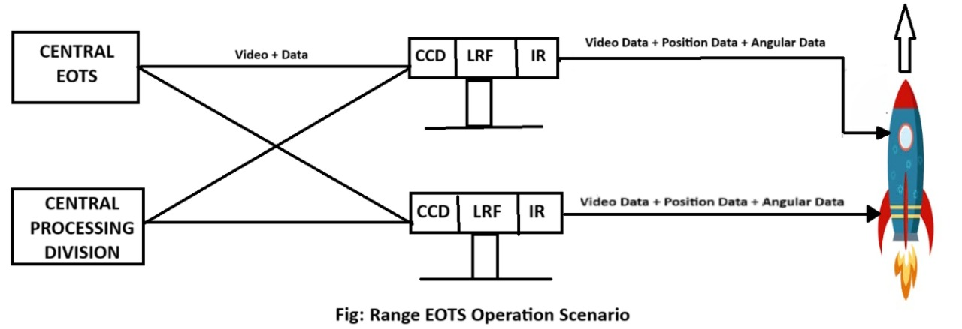

CRYPTOGRAPHY
What is Cryptography?
Cryptography is the science of securing information by transforming it into a form that unauthorized users cannot understand. It enables secure communication in the presence of malicious third parties, commonly known as adversaries.
Derived from the Greek words kryptos (hidden) and graphein (to write), cryptography essentially means “hidden writing.”[1]
Cryptography, though vital to modern electronic communication, has ancient origins. The earliest known use dates back to around 2000 B.C. in Egypt, where non-standard hieroglyphics were used to conceal messages. Since then, many civilizations with written language have employed some form of secret writing. Notable historical examples include the scytale cipher used in ancient Sparta and the Caesar cipher developed in ancient Rome—both early methods of protecting sensitive information.

While Cryptography is the science of secret writing aimed at concealing the meaning of a message, Cryptanalysis is the science — and often the art — of breaking cryptographic systems and uncovering hidden information.
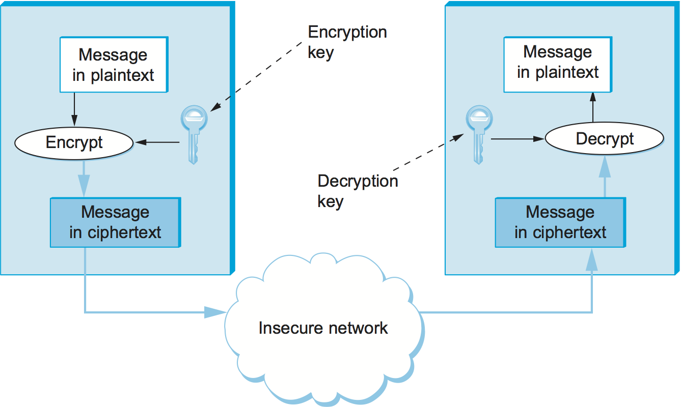

Symmetric Cryptography
Symmetric cryptography, also known as secret key cryptography, refers to a method where both parties share the same secret key for encryption and decryption. It is best suited for bulk encryption due to its speed and efficiency compared to asymmetric cryptography.
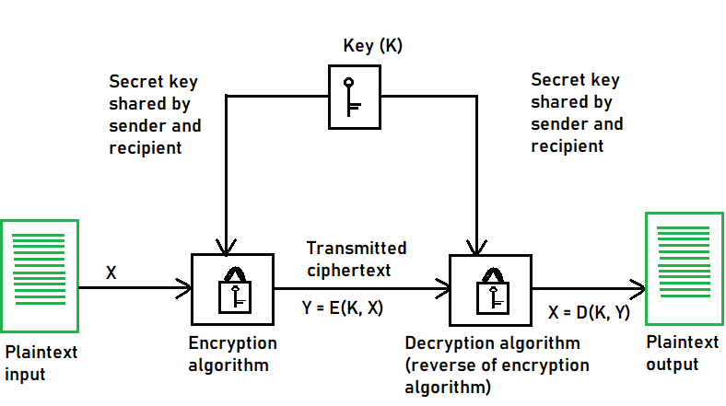
Types of Symmetric Key Cryptography:
1. Stream Ciphers
2. Block Ciphers
Stream Ciphers:
The encryption process begins with the stream cipher’s algorithm generating a pseudo-random keystream made up of the encryption key and the unique randomly generated number known as the nonce. The result is a random stream of bits corresponding to the length of the ordinary plaintext. Then, the ordinary plaintext is also deciphered into single bits. [2]
Block Cipher:
The result of a block cipher is a sequence of blocks that are then encrypted with the key. The output is a sequence of blocks of encrypted data in a specific order. When the ciphertext travels to its endpoint, the receiver uses the same cryptographic key to decrypt the ciphertext blockchain to the plaintext message.
The most common block cipher algorithms are:
1.Advanced Encryption Standard (AES)[3]:
- It has support for three-length keys: 128 bits, 192 bits, or 256 bits, the most commonly used one is a 128-bit key.
- It includes secure communication, data encryption in storage devices, digital rights management (DRM), and so on.
2. Data Encryption Standard (DES):
- In DES, the 64-bit blocks of plaintext are encrypted using a 56-bit key.
- This weakness caused by the small key size led to the development of a more secure algorithm, called AES.
3. Triple Data Encryption Algorithm (Triple DES):
- The development of the Triple DES, also called Triple-DES or TDEA, was triggered by the weak security resulting from the small key size in the DES.

Confusion and Diffusion
According to the famous information theorist Claude Shannon, there are two primitive operations with which strong encryption algorithms can be built:
1. Confusion: It is an encryption operation where the relationship between key and ciphertext is obscured. Today, a common element for achieving confusion is substitution, which is found in both DES and AES. [4]
2. Diffusion: It is an encryption operation where the influence of one plaintext symbol is spread over many ciphertext symbols with the goal of hiding statistical properties of the plaintext. A simple diffusion element is the bit permutation, which is used frequently within DES. AES uses the more advanced Mix column operation.
The Feistel Cipher structure:
Feistel Cipher model is a structure or a design used to develop many block ciphers such as DES. Feistel cipher may have invertible, non-invertible and self-invertible components in its design. Same encryption as well as decryption algorithm is used. A separate key is used for each round. However same round keys are used for encryption as well as decryption.
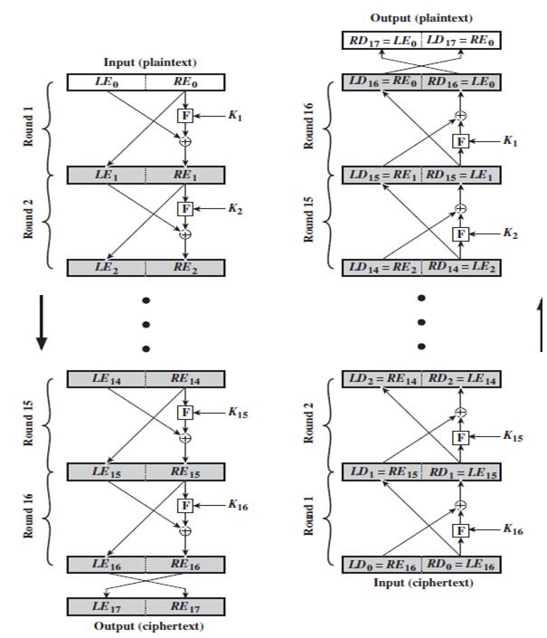

Data Encryption Standard (DES)
Data Encryption Standard (DES) is a symmetric block cipher. By 'symmetric', we mean that the size of input text and output text (ciphertext) is same (64-bits). The 'block' here means that it takes group of bits together as input instead of encrypting the text bit by bit. It is a block cipher that encrypts data in 64-bit blocks.
- It takes a 64-bit plaintext input and generates a corresponding 64-bit ciphertext output.
- The main key length is 64-bit which is transformed into 56-bits by skipping every 8th bit in the key.
- It encrypts the text in 16 rounds where each round uses 48-bit subkey.
- This 48-bit subkey is generated from the 56-bit effective key.
- The same algorithm and key are used for both encryption and decryption with minor changes.
Working of Data Encryption Standard (DES):
DES is based on the two attributes of Feistel cipher i.e. Substitution (also called confusion) and Transposition (also called diffusion). DES consists of 16 steps, each of which is called a round. Each round performs the steps of substitution and transposition along with other operations[5].
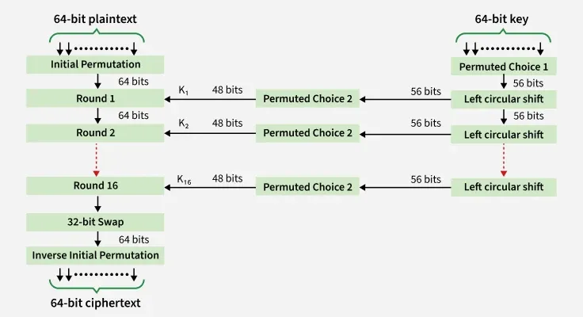
The DES (Data Encryption Standard) process involves several steps, organized into a series of rounds within a Feistel network structure. Here’s a breakdown of the steps:
1. Initial Permutation (IP):
The 64-bit plaintext block undergoes an initial permutation, where the positions of its bits are rearranged according to a predefined table.
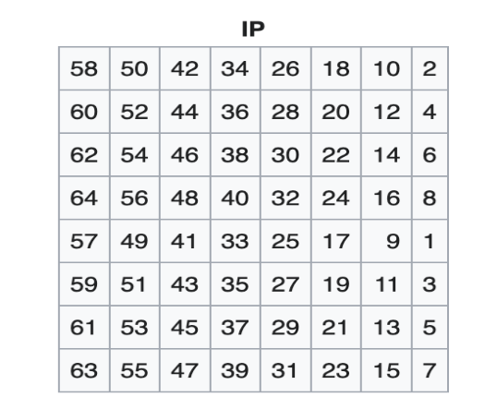
2. Key Generation:
The 56-bit key is expanded and divided into sixteen 48-bit subkeys, one for each round of encryption.
- Initial Key: The process begins with a 64-bit key, which is the user-provided secret key used to initiate the encryption.
- Key Permutation and Compression: 8-bit is being dropped and the 56-bit key undergoes an initial permutation (PC1 permutation) and compression. During this step, certain bits are selected and rearranged according to a predefined table. The result is a 56-bit permutation of the original key.
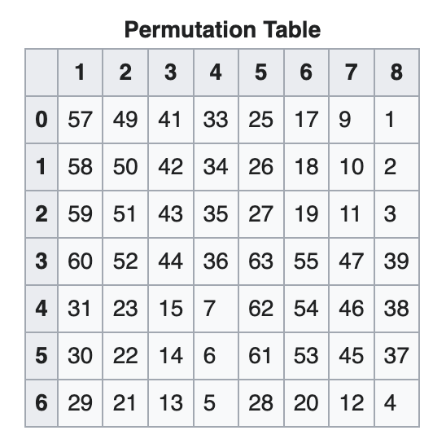
- Key Splitting: The 56-bit permuted key is then split into two 28-bit halves: a left half (C0) and a right half (D0).
- Left Shift: In each round, both the left and right halves of the key are independently rotated or shifted by a certain number of bits, creating a new combination of bits.
- Shift schedule = [1, 1, 2, 2, 2, 2, 2, 2, 1, 2, 2, 2, 2, 2, 2, 1]
- Concatenation and Compression: After the rotation, the left and right halves are concatenated and compressed to create a 48-bit round subkey for that specific round.
- Key Compression: The compression PC2 permutation changes the 56-bit key to the 48-bit key, which is used as a key for the corresponding round. Example: for round 1 we’ll use K1 and so on.
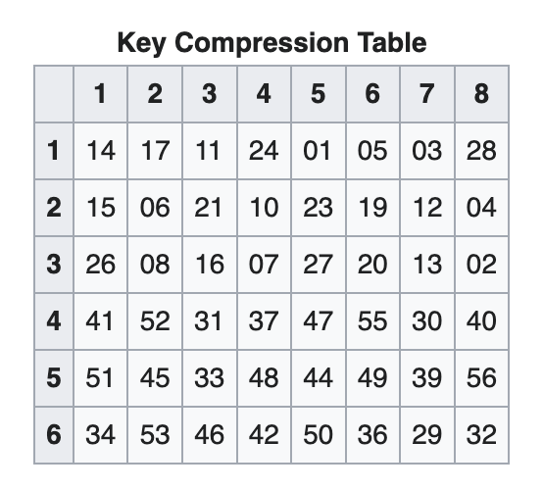
- Round-Specific Subkey Generation: The key expansion process involves creating sixteen round-specific subkeys, one for each round of encryption for C1 and D1 we’ll use C0 and D0 and for C2 and D2 we’ll use C1 and D1, and so on till C15 and D15.
- Sixteen Subkeys: This process is repeated for each of the sixteen rounds, resulting in a set of sixteen 48-bit subkeys (K1, K2, …, K16).

Advanced Encryption Standard (AES)

3. Rounds of Encryption:
- The data block is divided into two halves (L and R), and each round involves the transformation of one half based on the other half and the round key.
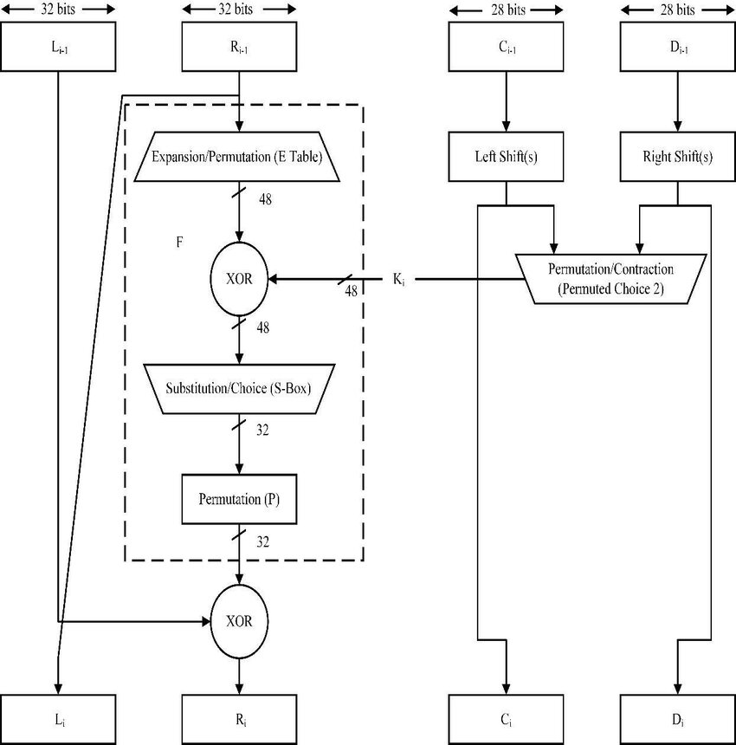
Single Round of Encryption:
- The f-Function:
the f-function plays a crucial role for the security of DES. In round 1 it takes the right half Ri−1 of the output of the previous round and the current round key ki as input. The output of the f-function is used as an XOR-mask for encrypting the left half input bits Li−1.
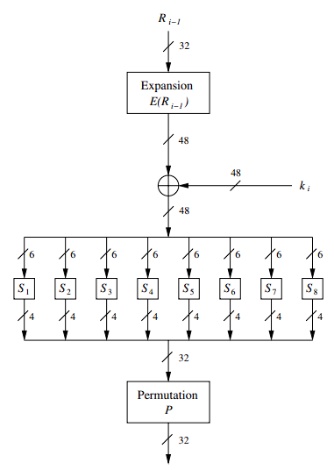
- Expansion/Permutation: The right half (R0) is subjected to an expansion operation, increasing its size (32-bit to 48-bit). This expanded right half is then XORed (bitwise exclusive OR) with the round-specific subkey (Ki) derived from the key schedule.
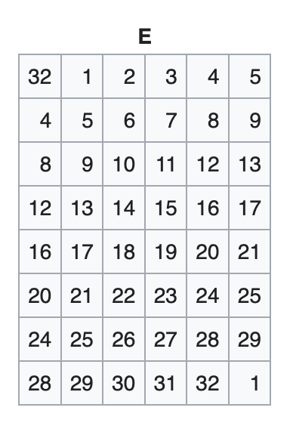
- Substitution (S-boxes): The result of the XOR operation is divided into eight 6-bit blocks. Each block is fed into a corresponding S-box (substitution box), which replaces it with a 4-bit output based on the S-box’s predefined substitution table. The outputs from all S-boxes are concatenated to form a 32-bit output.
- Permutation (P-Box): The 32-bit output from the S-boxes is subjected to a fixed permutation (P-box permutation). This rearranges the bits according to a predetermined permutation table.
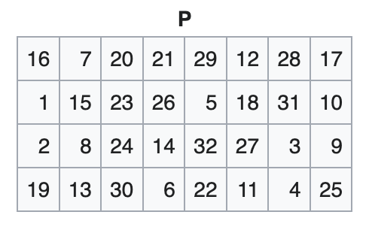
- XOR with Left Half: The output of the permutation step is XORed with the original left half (L0).
- Swap Left and Right Halves: The result of the XOR operation becomes the new right half (R1), and the original right half (R0) becomes the new left half (L1) for round 2 we’ll repeat these steps with respective key on L1 and R1 and so on.
- The transformation is accomplished through a combination of substitution (using S-boxes), permutation, and bitwise operations.
- The use of a different subkey for each round adds variability to the encryption process, enhancing security.
5. Final Permutation (FP): After the 16th round, the left and right halves are swapped one last time. The final result undergoes a final permutation (inverse of the initial permutation) to generate the 64-bit block of ciphertext.
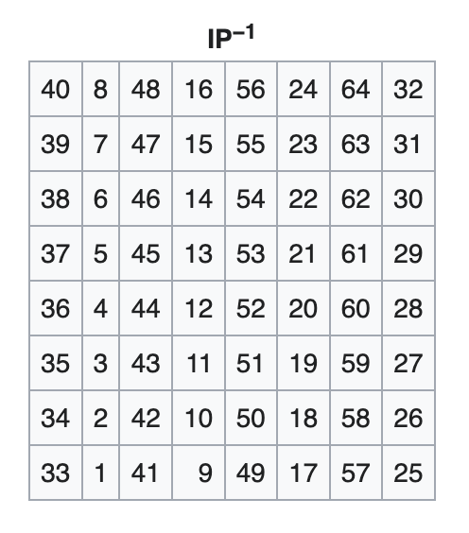

Implementation of DES using Python
Code for Encryption:

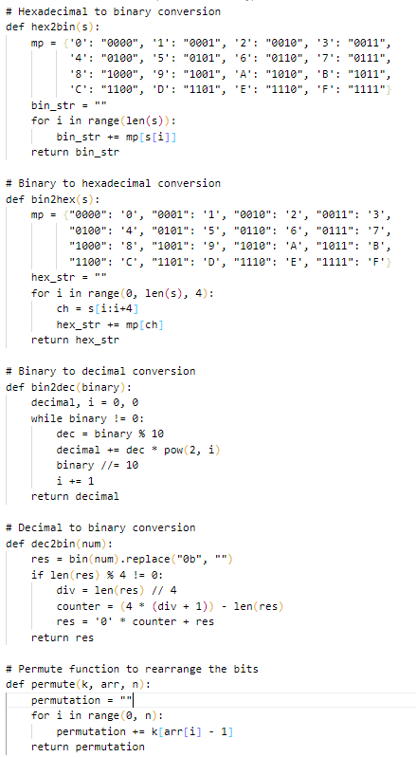
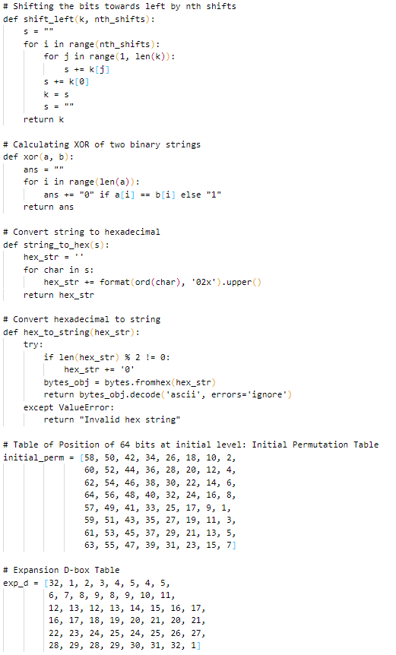

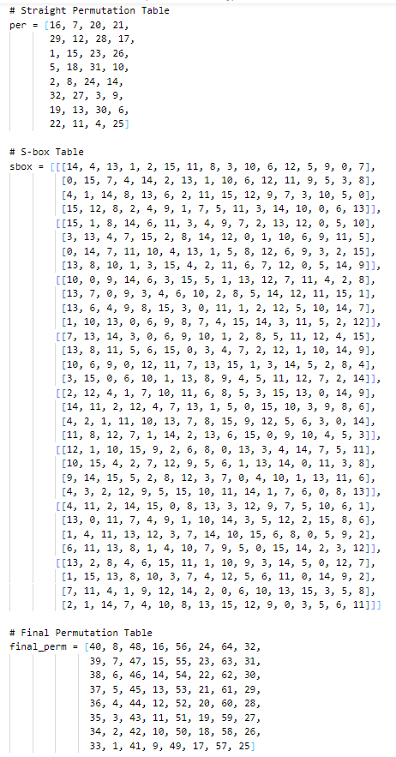
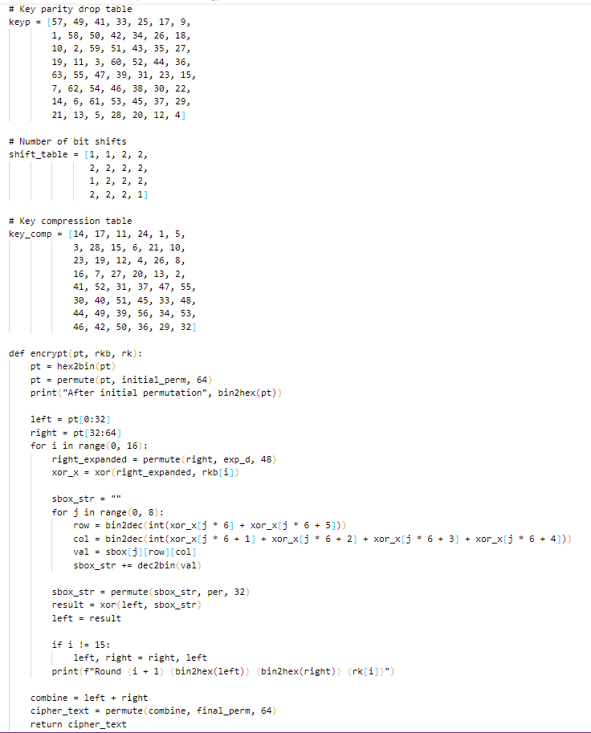

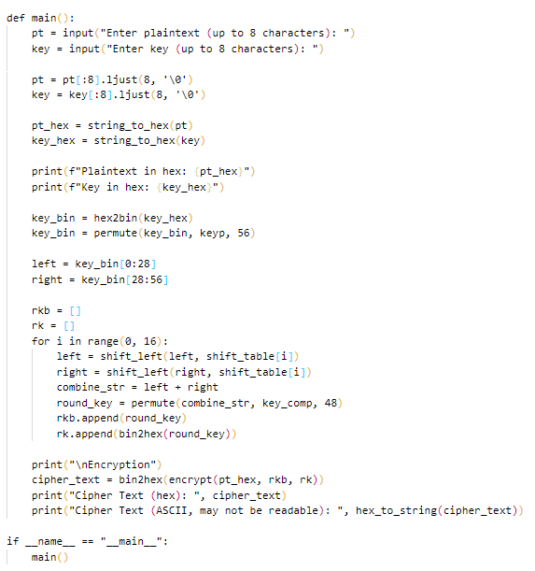
OUTPUT:

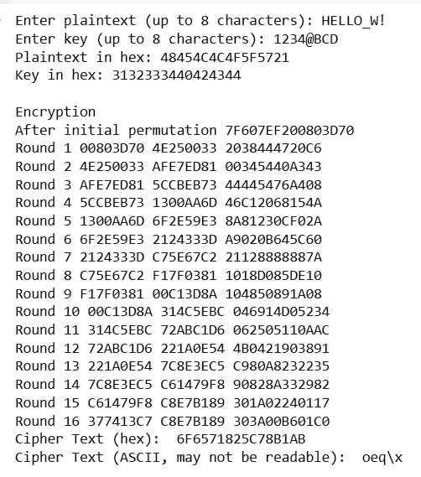

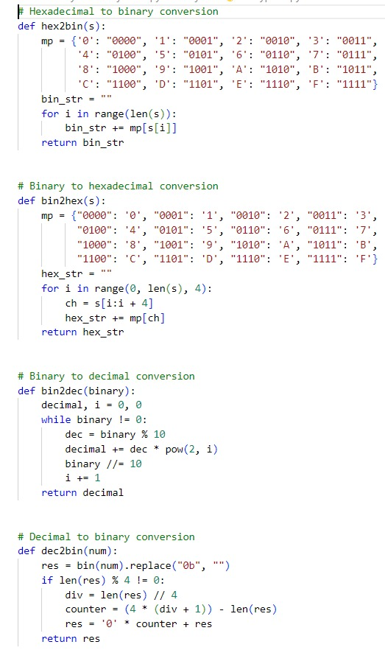
Code for Decryption

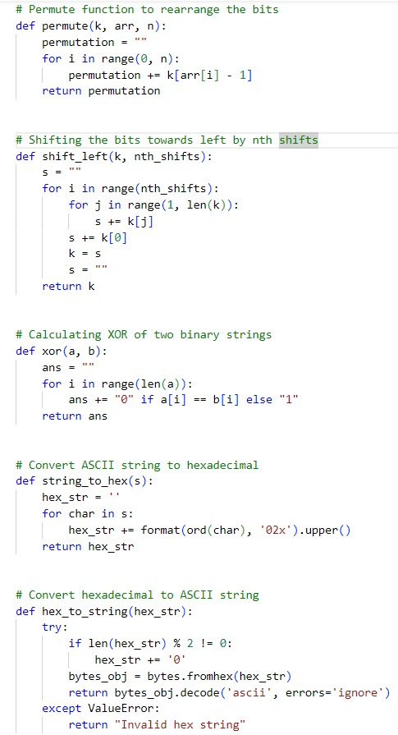

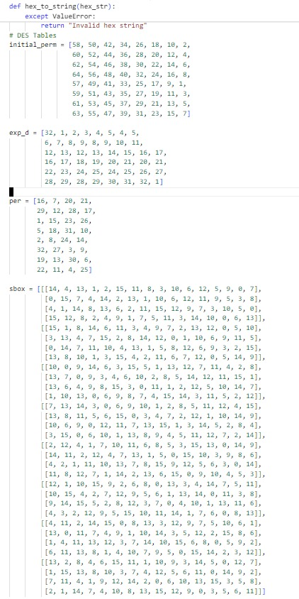

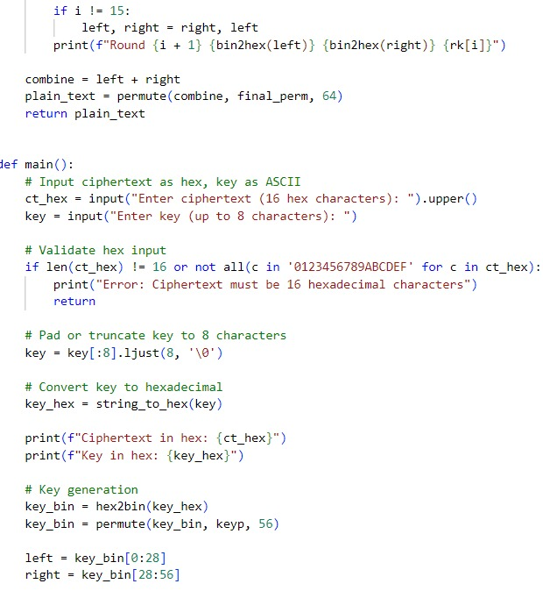
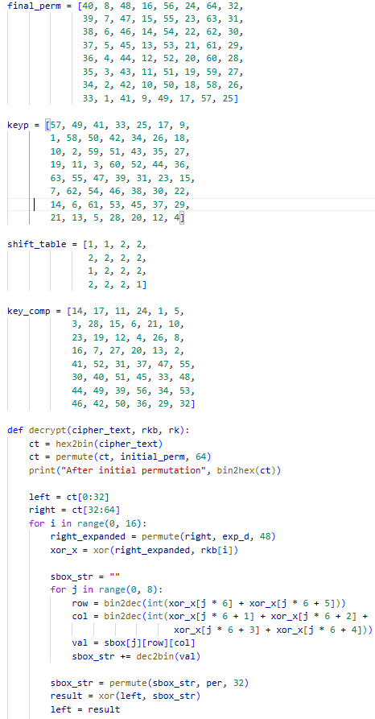

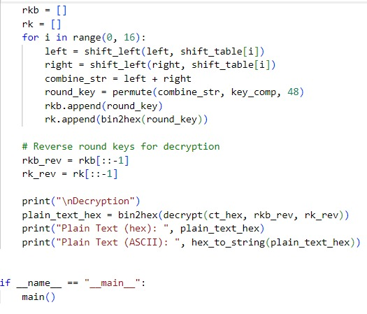
OUTPUT:
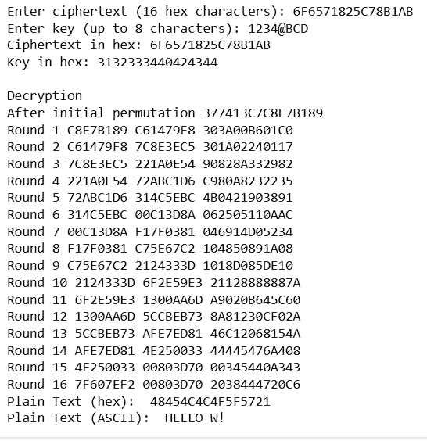

Asymmetric Cryptography
Definition
Asymmetric cryptography, also known as public-key cryptography, uses a pair of keys — a public key and a private key — to encrypt and decrypt data. The public key is shared openly and used for encryption, while the private key is kept secret and used for decryption. This eliminates the need to share a single secret key and significantly enhances security, especially for digital communications over open networks. Asymmetric cryptography is widely used in secure email, digital signatures, and online transactions. Common algorithms include RSA (Rivest–Shamir–Adleman) and Elliptic Curve Cryptography (ECC)[6].

It is widely used in:
- 🔐 Secure communication
- 📝 Digital signatures
- 🌐 SSL/TLS for secure websites
- 📱 End-to-end encryption in messaging apps
- 🧾 Verifying documents and software updates

Here’s An Example of Alice and Bob using Asymmetric Cryptography
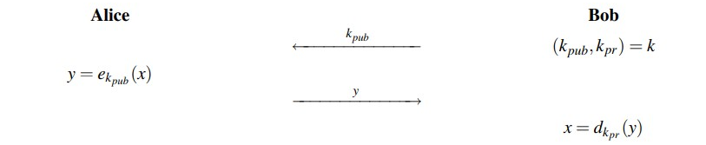
Bob generates a key pair:
- Public key (kpub) – shared with everyone
- Private key (kpr) – kept secret
Alice wants to send a secret message to Bob:
- She encrypts the message using Bob’s public key (kpub)
Bob receives the encrypted message:
- He decrypts it using his private key (kpr)

RSA
In 1977, Ronald Rivest, Adi Shamir and Leonard Adleman proposed a scheme which became the most widely used asymmetric cryptographic scheme called RSA. RSA is a public-key cryptosystem that is used for secure data transmission, especially in applications like secure emails, digital signatures, and online transactions. It is based on the mathematical difficulty of factoring large prime numbers — a problem that is easy to verify but extremely hard to reverse.
RSA uses two keys:
- A public key for encryption (shared openly)
- A private key for decryption (kept secret)
Anyone can use the public key to encrypt data, but only the holder of the private key can decrypt it. Before the application of RSA, some prerequisite knowledge on Fermat’s(little) Theorem and Euler’s Theorem are required[7].

Fermat’s (little) Theorem
Fermat’s Little Theorem is a fundamental result in number theory. It states:
If p is a prime number and a is an integer such that a is not divisible by p, then:
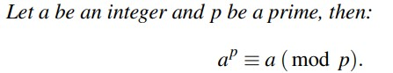
Fermat’s Little Theorem is fundamental to public-key cryptography, particularly:
- RSA algorithm (used in modular arithmetic and modular inverses)
- Fast modular exponentiation
- Finding large prime numbers
- Modular inverse calculation (e.g., computing private keys)
Modulo Multiplicative Inverse
The modulo multiplicative inverse of an integer a modulo n is an integer x such that:
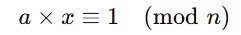

Euler’s Theorem
Euler’s Theorem is a generalization of Fermat’s Little Theorem. It states:
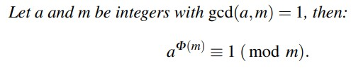
Where:
- φ(n) is Euler’s totient function, which counts the number of integers less than n that are coprime to n.
It is used in RSA to compute the modular inverse of the public exponent e, which helps generate the private key d:
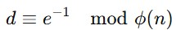
Relationship with Fermat’s Theorem
Fermat's Little Theorem is a special case of Euler’s Theorem when n is a prime number:
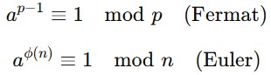

ALGORITHM
1. Key Generation
The process of creating a matching pair of public and private keys for secure communication.
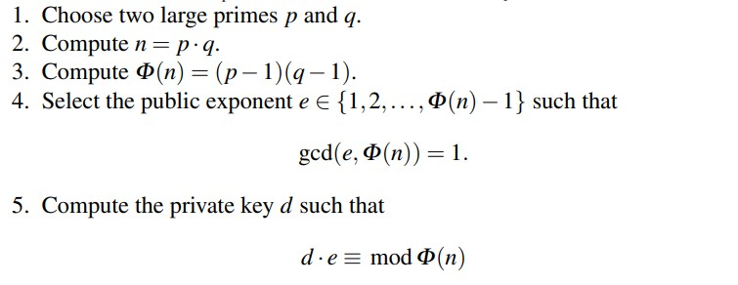
🔓 Public Key: (e, n) – shared with everyone
🔒 Private Key: (d, n) – kept secret

2. Encryption
The process of converting a plaintext message into an unreadable ciphertext using the recipient's public key.
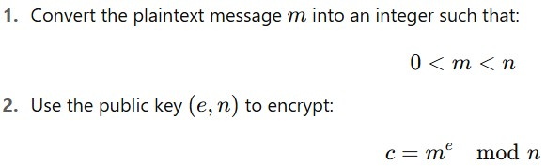
Where:
c is the ciphertext

3. Decryption
The process of converting the ciphertext back into the original plaintext using the private key.
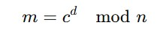
Where:
c = the encrypted message (ciphertext)
d = private exponent
n = modulus
m = original plaintext message

Implementation of RSA using Python
1. Key Generation
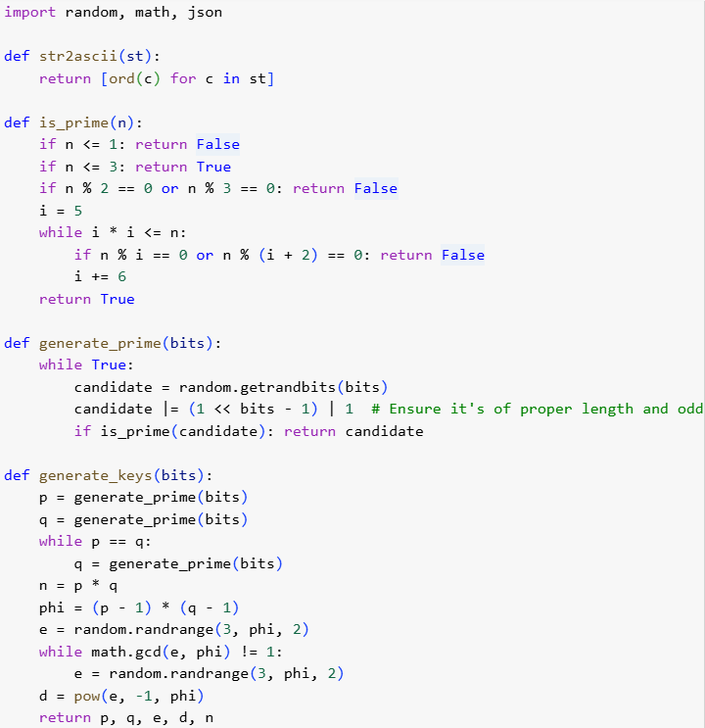

2. Encryption
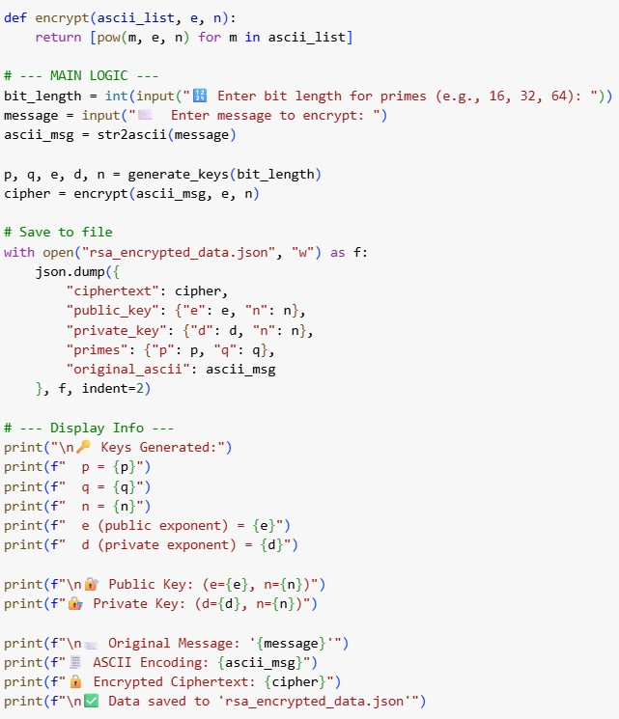

Output
🔢 Enter bit length for primes (e.g., 16, 32, 64): 18
✉️ Enter message to encrypt: NEWPROJECT

🔑 Keys Generated:
p = 164299
q = 235177
n = 38639345923
e (public exponent) = 25962231703
d (private exponent) = 34470784807

🔐 Public Key: (e=25962231703, n=38639345923)
🔏 Private Key: (d=34470784807, n=38639345923)

📨 Original Message: 'NEWPROJECT'
🧾 ASCII Encoding: [78, 69, 87, 80, 82, 79, 74, 69, 67, 84]
🔒 Encrypted Ciphertext: [28992306408, 13413407240, 17344499723,
4526239047, 35332784591, 15496763047, 18893364312,
13413407240, 33727538030, 19625484893]
✅ Data saved to 'rsa_encrypted_data.json'

3. Decryption 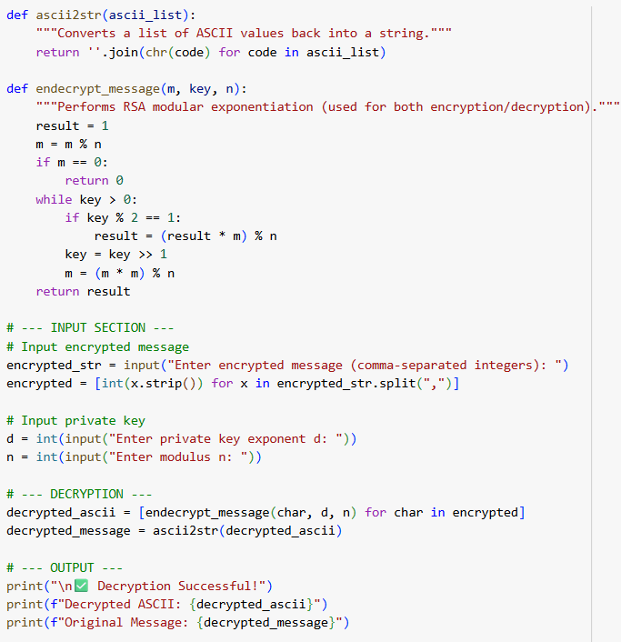

OUTPUT
Enter encrypted message (comma-separated integers): 28992306408, 13413407240, 17344499723, 4526239047, 35332784591, 15496763047, 18893364312, 13413407240, 33727538030, 19625484893
Enter private key exponent d: 34470784807
Enter modulus n: 38639345923

✅ Decryption Successful!
Decrypted ASCII: [78, 69, 87, 80, 82, 79, 74, 69, 67, 84]
Original Message: NEWPROJECT

Comparison between Symmetric and Asymmetric Cryptography

Symmetric cryptography uses the same secret key for both encryption and decryption, making it very fast and efficient for large data. However, sharing the key securely is a challenge. Examples include AES, DES, and Blowfish. In the DES example, after multiple rounds of substitutions and permutations using the secret key, the output was a 64-bit ciphertext (6F6571825C78B1AB), which was then successfully decrypted back into the plaintext (HELLO_W!). The intermediate rounds showed how the data was split into left and right halves and mixed using the key, demonstrating that symmetric encryption is highly effective at producing encrypted blocks and recovering the original message with minimal computational overhead.
Asymmetric cryptography uses a public key to encrypt and a private key to decrypt, so the private key never needs to be shared. This provides better security for key exchange and is often used for digital signatures and SSL/TLS. Examples include RSA, ECC, and DSA. In the RSA example, we used 18-bit primes for demonstration, and the output was a list of large integers (e.g. [28992306408, 13413407240, ...]). The private exponent was also a large number, and decryption successfully recovered the ASCII representation of the message (NEWPROJECT) after substantial computation using modular exponentiation. These outputs highlight the greater mathematical complexity and computational cost of public-key encryption.
Together, both symmetric and asymmetric cryptography yielded distinct types of outputs that highlight their different purposes and efficiencies in securing Range EOTS data. Symmetric encryption produces compact, block-wise encrypted data quickly and efficiently, making it ideal for continuous telemetry, video, or large data streams. In contrast, asymmetric encryption generates larger numeric outputs and is slower, making it more practical for securely exchanging keys or signing critical control messages. By combining these approaches, Range EOTS can establish a secret key securely using RSA, then use DES or another symmetric algorithm to protect large volumes of data at high speed — ensuring robust and practical end-to-end security for all operations.

Conclusion
Cryptography plays a critical role in safeguarding sensitive data in Range EOTS at test facilities like ITR, DRDO. Both symmetric and asymmetric encryption techniques contribute to protecting communications, telemetry, video feeds, and control signals. Symmetric cryptography enables fast and efficient encryption of large volumes of real-time data—ensuring that video streams, sensor readings, and test-range data remain confidential and intact. Meanwhile, asymmetric cryptography provides a robust mechanism for secure key exchange, authentication, and access control, ensuring that only authorized personnel can decrypt data or send valid commands to range instruments. Together, these methods guarantee the integrity, confidentiality, and authenticity of all test-range information, strengthens the security and operational reliability of Range EOTS systems in high-stakes defence environments.
In modern systems, both methods are often used together in a hybrid approach. Asymmetric encryption is used to exchange a symmetric session key, and then symmetric encryption takes over to handle the data transfer efficiently. This combination leverages the strengths of both techniques, ensuring both security and performance.
As technology advances, especially with the rise of quantum computing and interconnected devices, cryptography will continue to evolve — but its core purpose remains the same: to protect information in a world that increasingly depends on it.

Reference
- Christof Paar and Jan Pelzl, Understanding Cryptography – A Textbook for Students and Practitioners, First Edition, Springer, pp. 55-75, 2010
- William Stallings, Cryptography and Network Security
- Ganesh Ramani, Niraj Kumar, B K Das, Comprehensive Multimedia Encryption System Generalization and Comparison
- Alfred Menezes, Paul van Oorschot, and Scott Vanstone, Handbook of Applied Cryptography
- Bruce Schneier, Applied Cryptography – Protocols, Algorithms, and Source Code in C, 2nd Edition, Wiley, pp. 120–145, 1996
- Niels Ferguson, Bruce Schneier, and Tadayoshi Kohno, Cryptography Engineering – Design Principles and Practical Applications, 1st Edition, Wiley, pp. 60–95, 2010
- Jean-Philippe Aumasson, Serious Cryptography – A Practical Introduction to Modern Encryption, 1st Edition, No Starch Press, pp. 200–235, 2017
- Symmetric Key Cryptography - GeeksforGeeks

